**CASH FLOW MASTER**

**A PROJECT REPORT**

Submitted By

**SHAIK AYMAN HAMEED BAIG**

**eg. No.**



**LALAJI MEMORIAL OMEGA INTERNATIONAL SCHOOL, OMEGA SCHOOL ROAD, KOLAPAKKAM, CHENNAI- 600128**

**MARCH 2024**



***BONA-FIDE CERTIFICATE***

## SUBJECT: COMPUTER SCIENCE

**REGISTRATION NO.: __________________**

Certified to be the *bona-fide* record of work done by

**Shaik Ayman Hameed Baig**

of **Classes XII A** as **PROJECT** in the topic

**CASHFLOWMASTER**

at **Lalaji Memorial Omega International School, Chennai 600128** during the academic year **2023 -2024**. Submitted for **SSCE Examination 2024** held on

**Seal Principal**

**Date: Internal Examiner External Examiner**

**ACKNOWLEDGEMENT**

The satisfaction and euphoria of the successful completion of any task would be incomplete without the mention of the people who made it possible.

The constant guidance of these people and encouragement provided by them crowned my efforts with success and glory. I consider it as a privilege to express my gratitude to all those who led and guided me during the course of this project.

First and foremost, I would like to express my gratitude to the **MANAGEMENT** of my school for making it possible for me to be a part of this project.

I would like to convey my sincere regards to **Mrs. MAHESWARI** and **Mr. VETRIKUMARAN**, my internal guides for their valuable suggestions and necessary guidance during the course of the project.

I also take esteem privilege to thank the **TEACHERS**, who has been the very backbone and a catalyst for the success behind the completion of this project.

Last but not the least I thank my **PARENTS AND FRIENDS** who had been constant source of inspiration for the completion of this project.

**INDEX**

|  |  |  |
| --- | --- | --- |
| **S. No.** | **Content** | **Pg. No** |
| 1 | INTRODUCTION |  |
| 2 | HARDWARE REQUIREMENTS |  |
| 3 | IMPORTED MODULES AND FUNCTIONS USED |  |
| 5 | PROGRAM FRONT END |  |
| 6 | PROGRAM BACK END |  |
| 7 | TABLES CREATED IN MYSQL |  |
| 8 | OUTPUT WINDOWS |  |
| 9 | MERITS AND DEMERITS |  |
| 10 | CONCLUSION |  |
| 11 | BIBLIOGRAPHY |  |

**INTRODUCTION**

CashFlowMaster emerges as a sophisticated computer science endeavor, presenting an all-encompassing portfolio manager crafted through the synergy of Python, Tkinter, and MySQL. At its core, this project aims to revolutionize personal financial management by delivering a feature-rich, user-friendly Graphical User Interface (GUI). Functioning as a multi-user platform, CashFlowMaster securely stores and organizes diverse financial information, offering individuals a centralized hub for comprehensive portfolio tracking.

A standout feature is its adept handling of assets and expenditures, providing users with a nuanced understanding of their financial health. The incorporation of MySQL ensures robust and secure data storage, safeguarding sensitive financial details. The real brilliance of CashFlowMaster lies in its ability to generate dynamic visualizations, such as pie charts, offering users an intuitive representation of their net worth. This visual approach enhances financial comprehension, aiding users in making informed decisions about their assets and expenses.

Through the innovative integration of Python and Tkinter, CashFlowMaster not only demonstrates technical prowess but also prioritizes a seamless and interactive user experience. By merging cutting-edge technologies, CashFlowMaster emerges as a powerful tool for diverse individuals seeking efficient financial planning and portfolio management. This project is a testament to the potential of computer science in transforming traditional financial practices into dynamic, user-centric experiences.

**HARDWARE REQUIREMENTS**

CPU : Multicore processor minimum 2 cores and 2Ghz clock speed

RAM : Minimum 4GB DDR2

STORAGE : 8Gb of free space (SSD preferred)

GPU : any dedicated graphics card (post 2010)

NOTE : THE HARDWARE SHOULD SUPPORT PYTHON 3.10 OR LATER

**IMPORTED MODULES AND FUNCTIONS USED**

1. **GUI Functions**

import tkinter as tk

import matplotlib.pyplot as plt

from matplotlib.figure import Figure

from matplotlib.backends.backend_tkagg import FigureCanvasTkAgg

1. **SQL Functions**

import mysql.connector as m

**PROGRAM FRONT END**

|  |  |  |
| --- | --- | --- |
| **S. No.** | **Content** | **Pg. No** |
| 1 | LOGIN PAGE |  |
| 2 | CREATE USER PAGE |  |
| 3 | PAGE 2 |  |
| 5 | PAGE 3 (DATA ENTRY) |  |
| 6 | PAGE 4 (DATA GRAPH) |  |
| 7 | USER CSV |  |
| 8 | ASSETS CSV |  |
| 9 | MONTHLY REPORT CSV |  |
| 10 | CONCLUSION |  |

**LOGIN PAGE**

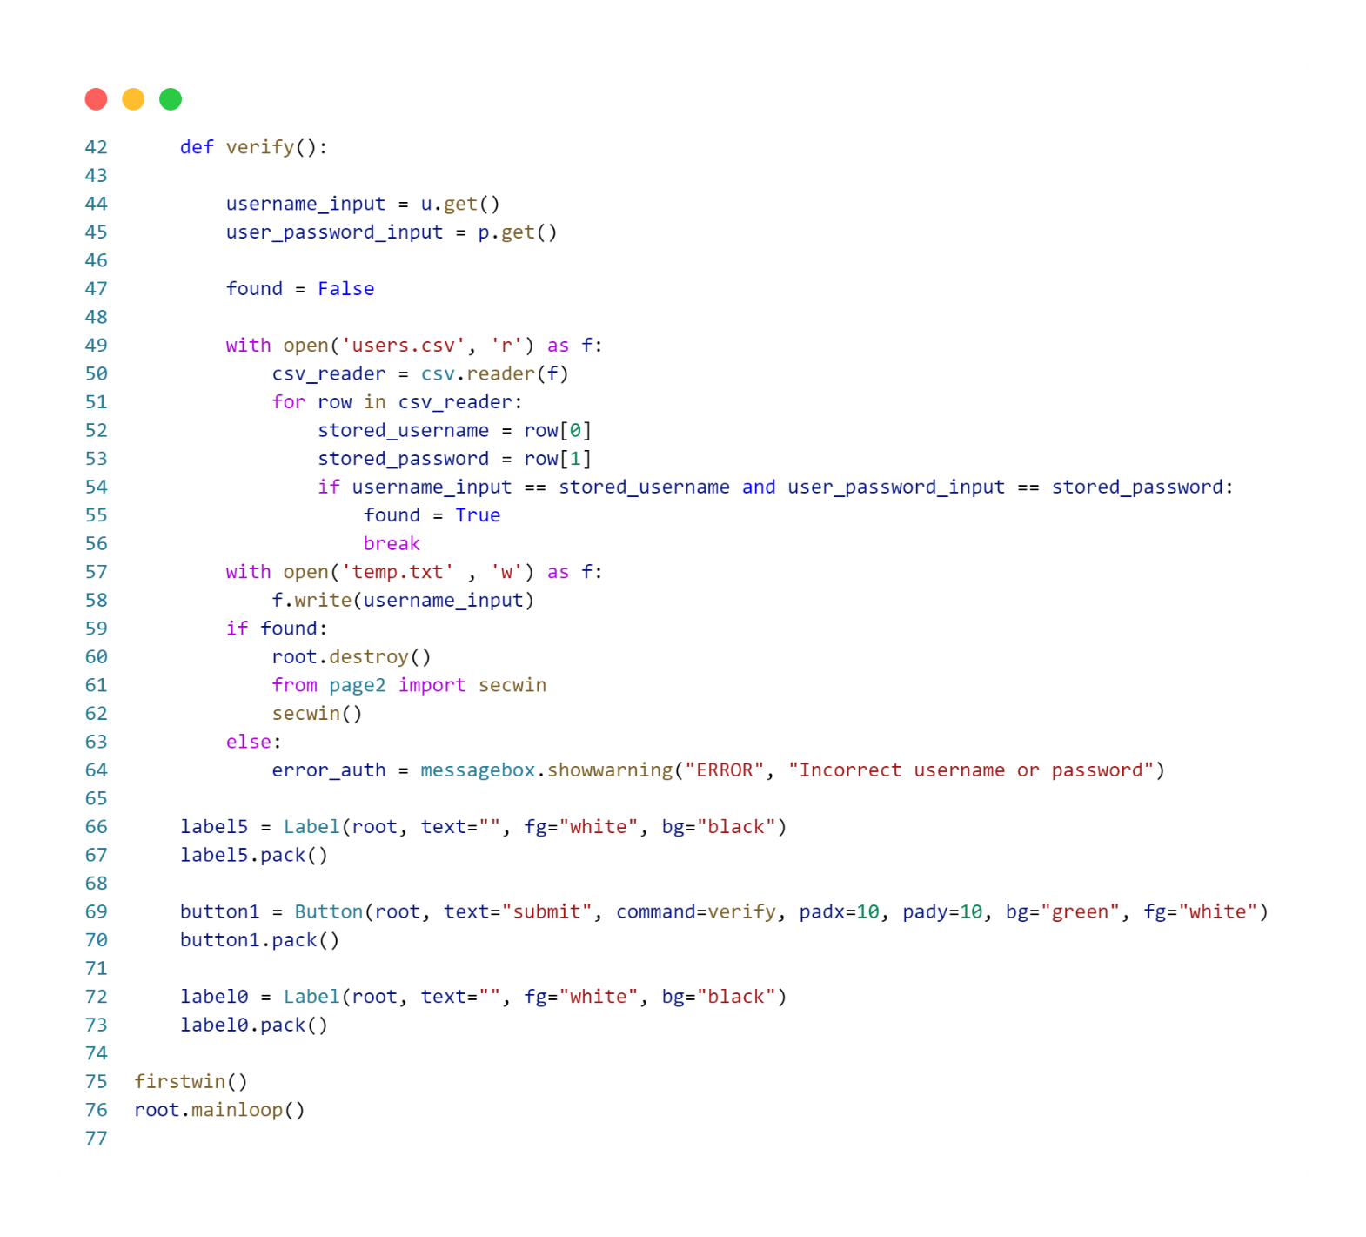

**CREATE USER PAGE**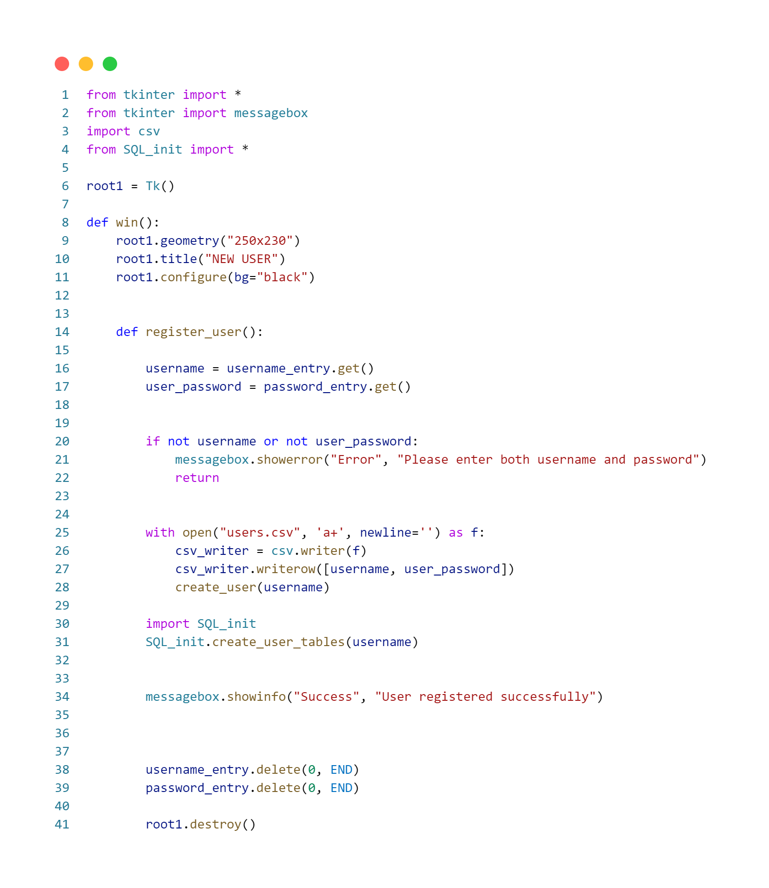

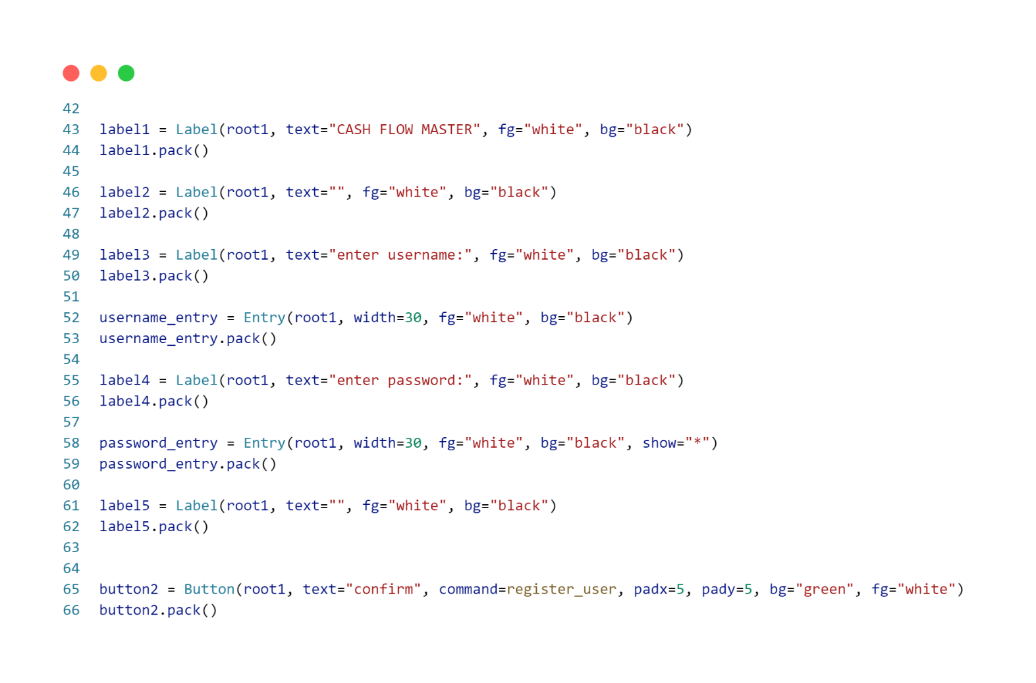

**PAGE 2 (BUTTON PAGE)**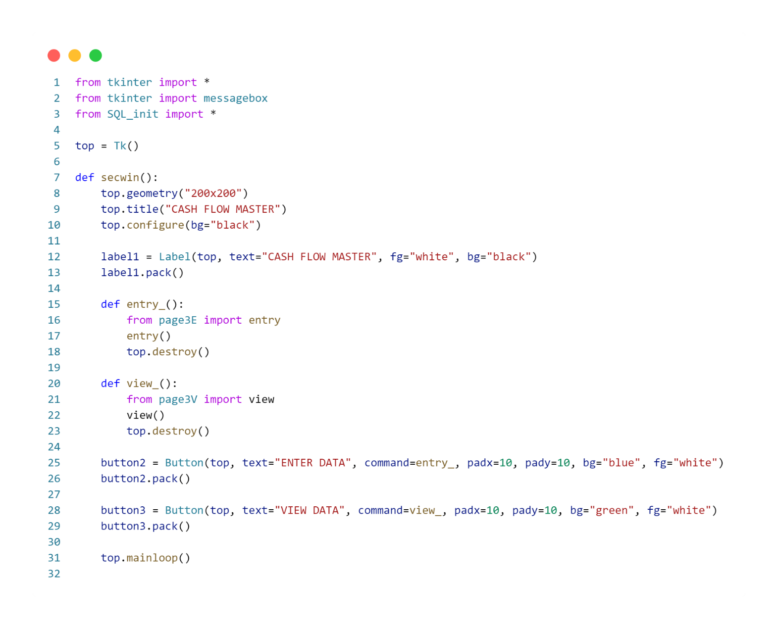

**PAGE 3 (DATA ENTRY)**

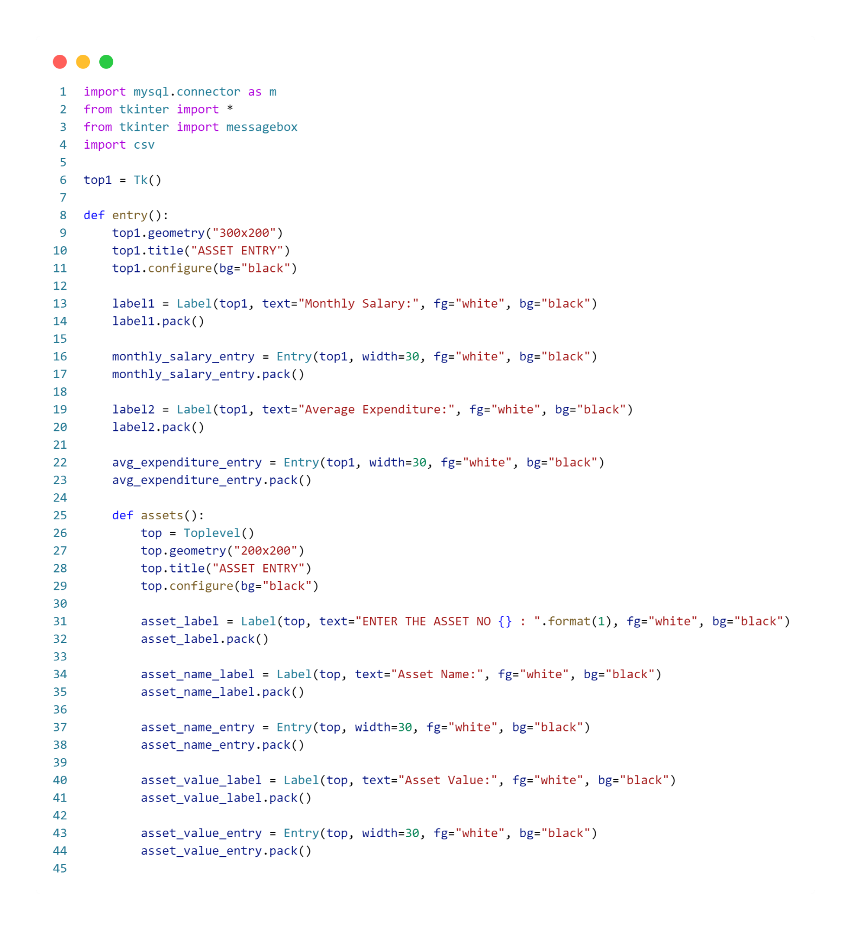

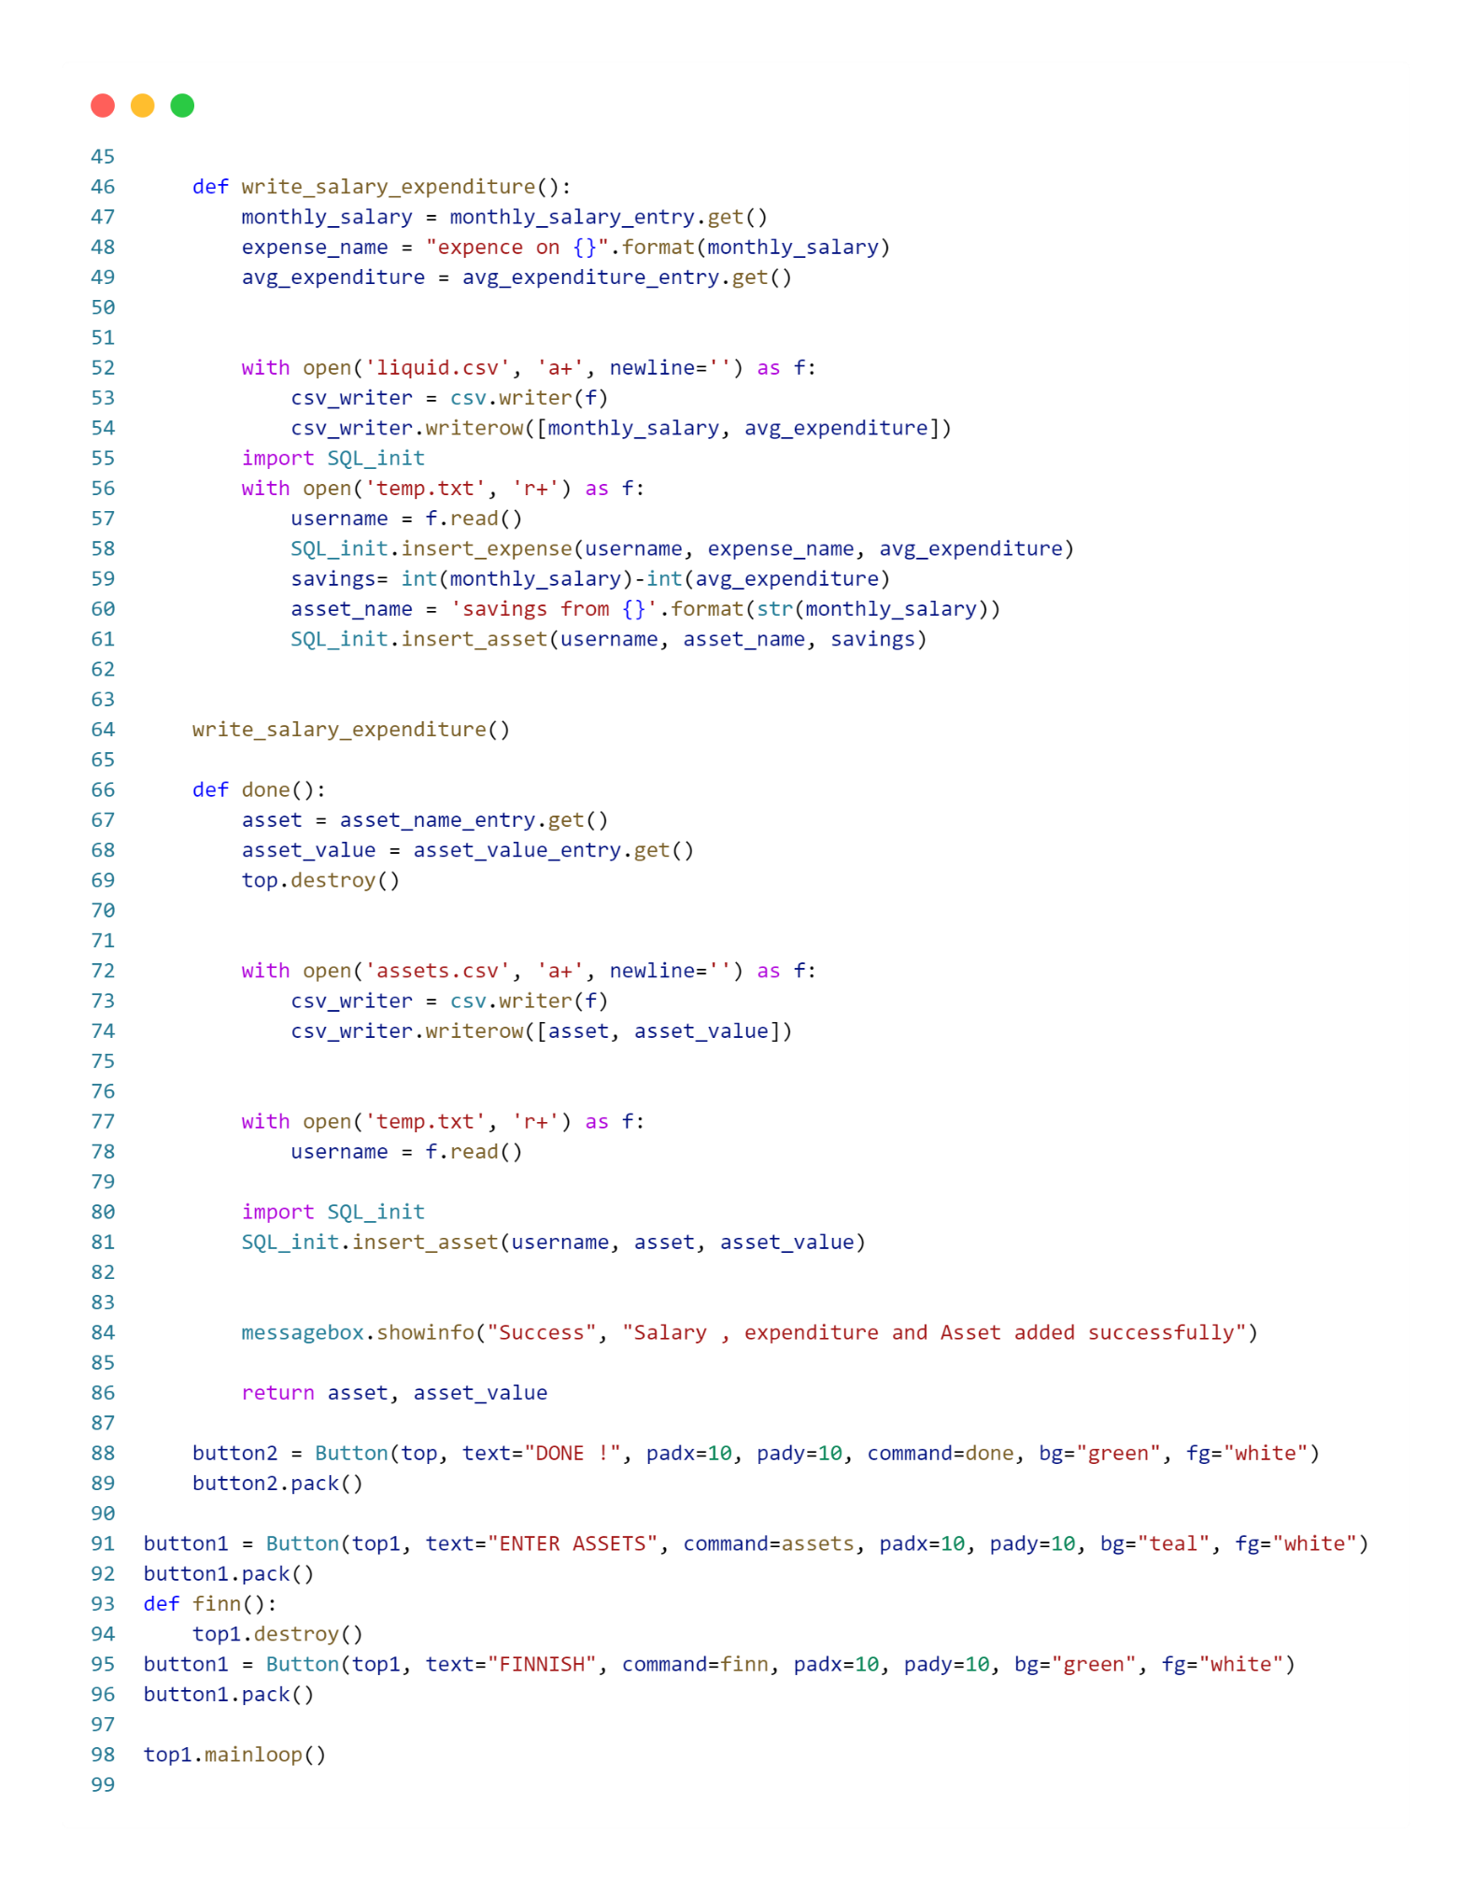

**PAGE 4 (DATA GRAPH)**

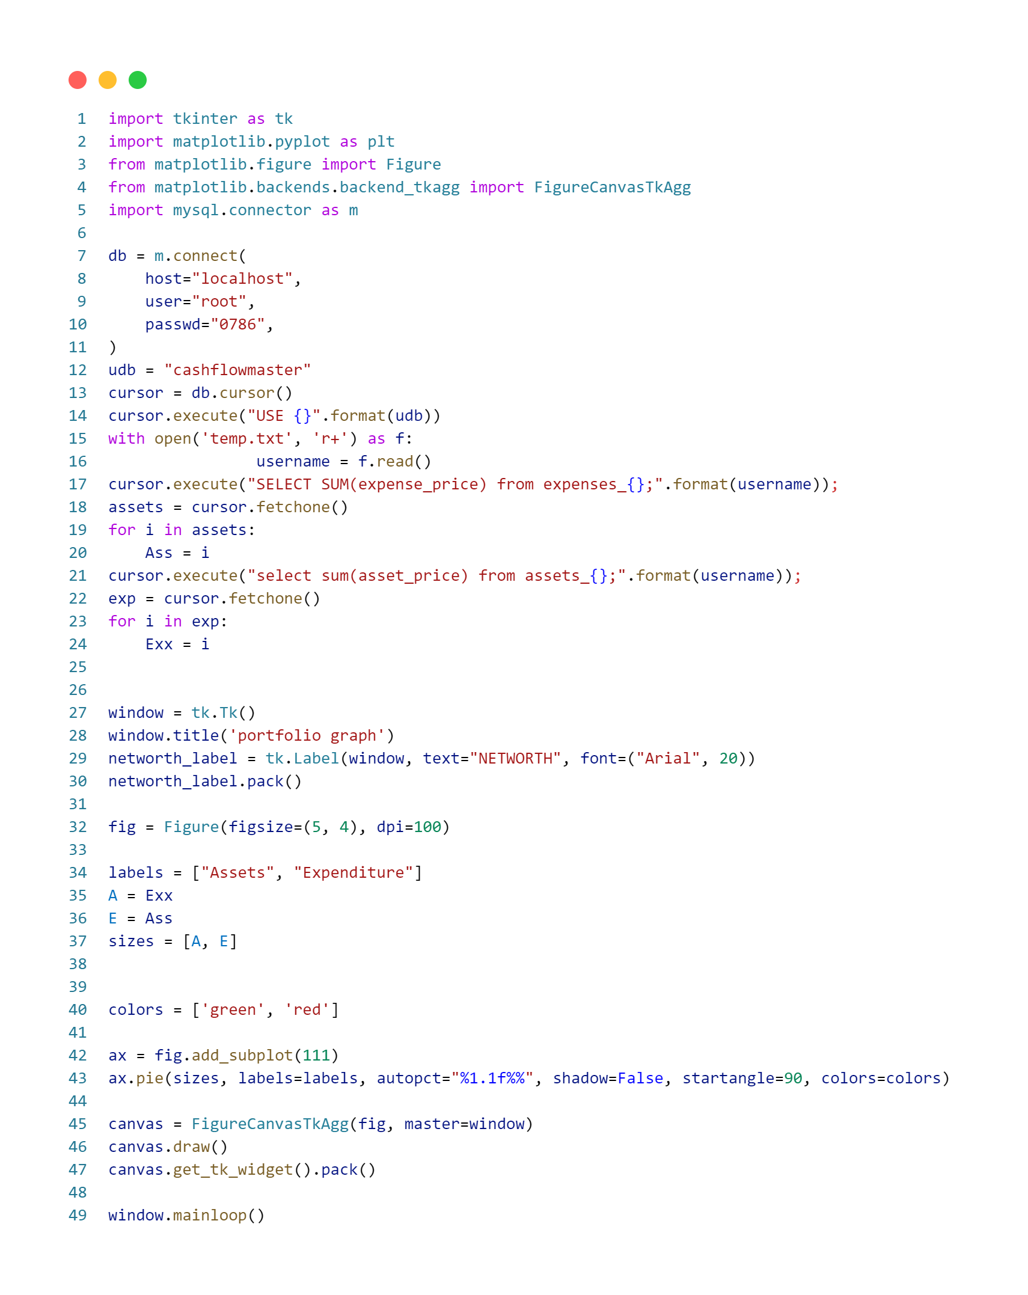

**USER CSV**

**ASSETS CSV**

**MONTHLY REPORT CSV**

**NOTE: SAVINGS ARE ADDED AS AN ASSET**

**PROGRAM BACK END**

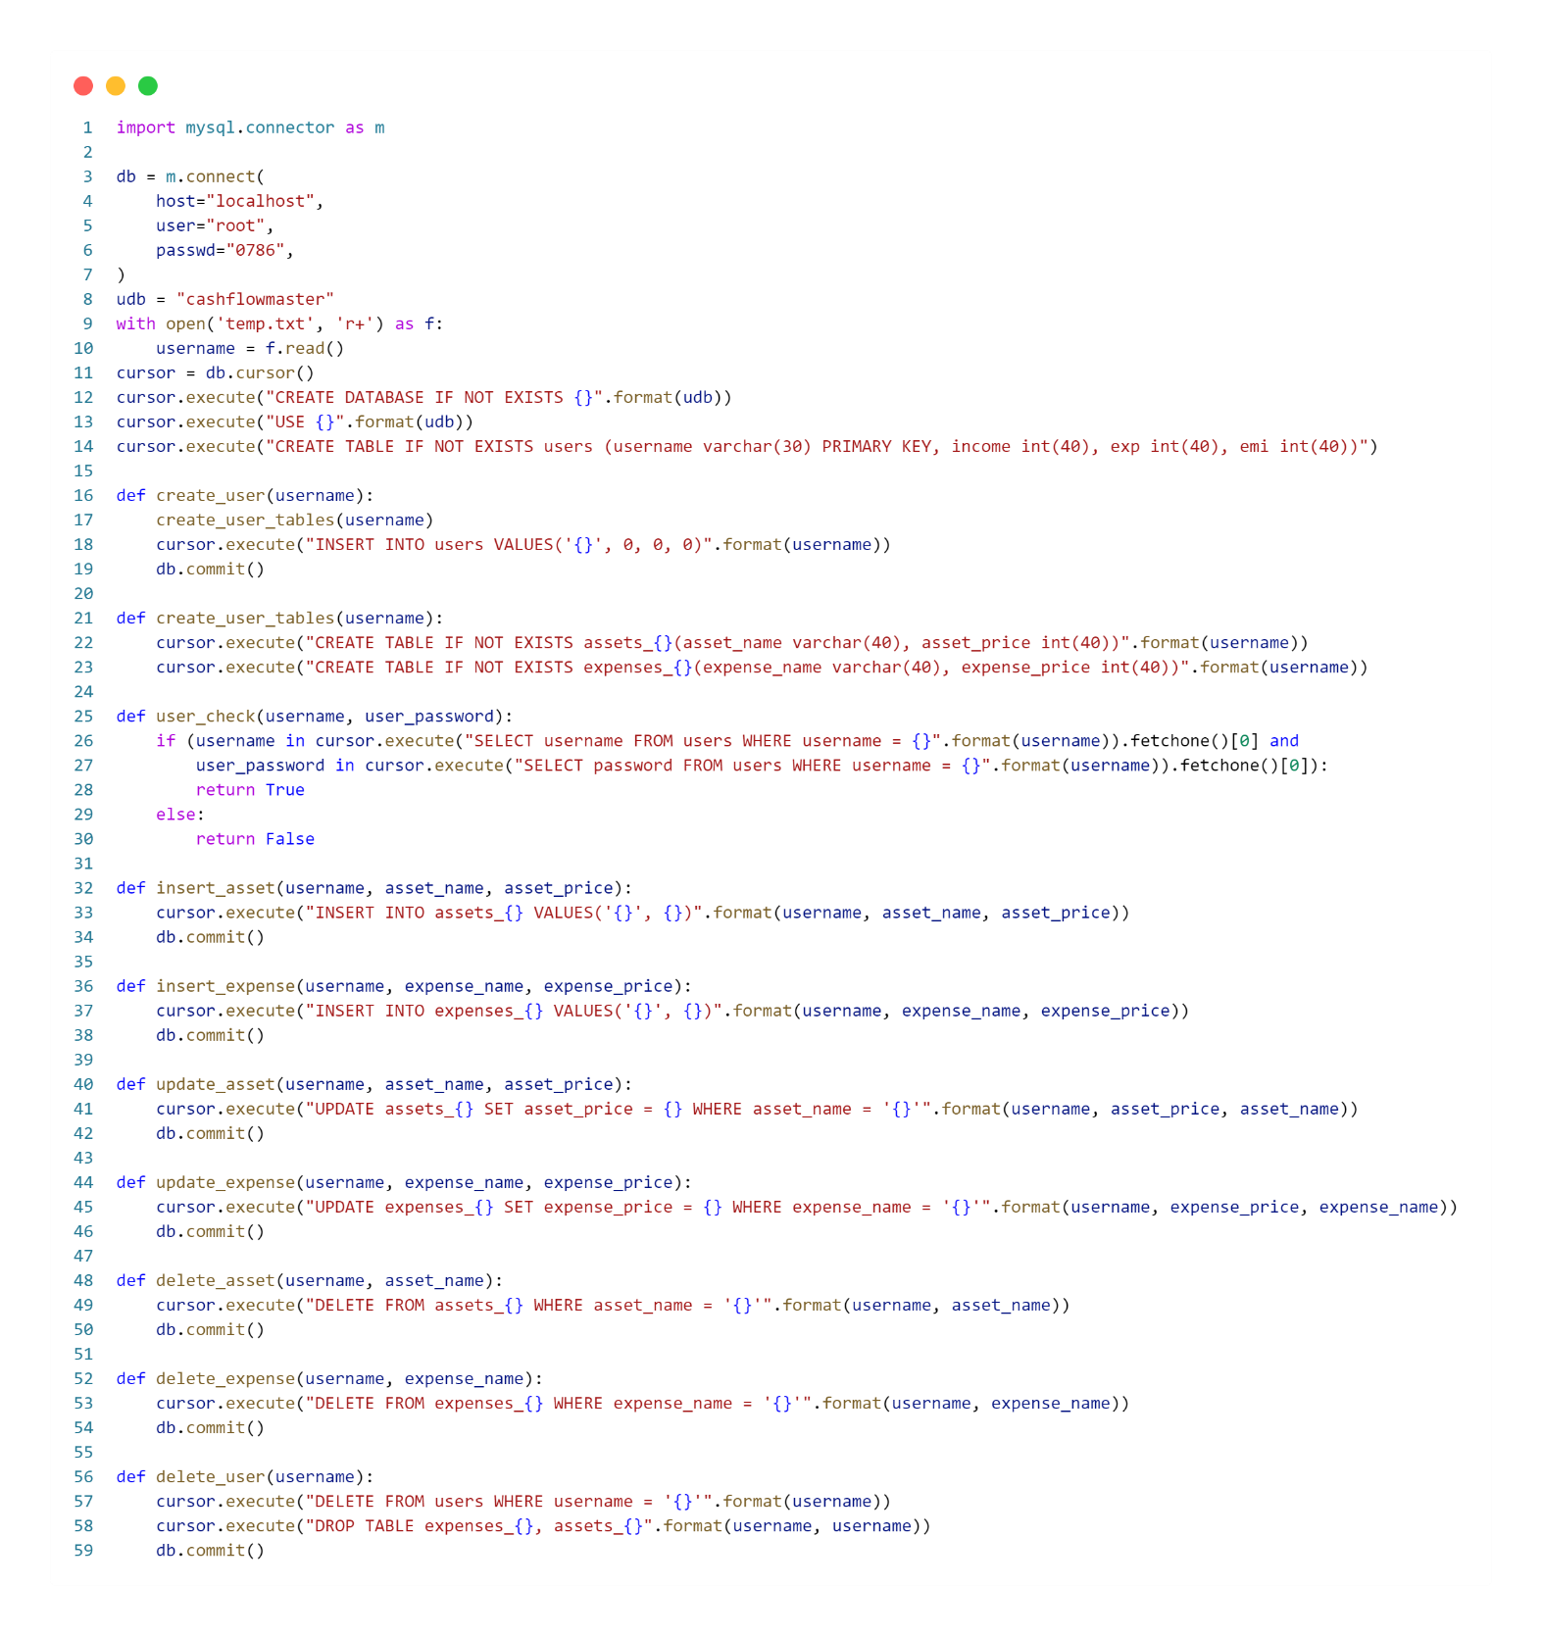

**TABLES CREATED IN MYSQL**

**OUTPUT WINDOWS**

**LOGIN PAGE:**

**NEW USER:**

**PAGE 2:**

**ENTER DATA:**

**VIEW DATA:**

**METRITS AND DEMETRITS**

Merits:

Comprehensive Portfolio Management: CashFlowMaster provides a holistic solution for portfolio management, enabling users to track and manage their assets and expenditures in one centralized platform.

User-Friendly GUI: The inclusion of a Graphical User Interface (GUI) built with Tkinter enhances the user experience, making it accessible and intuitive for individuals with varying levels of technical expertise.

Multi-User Support: The project supports multiple users, making it versatile for families or small businesses to manage their financial information separately within the same application.

Secure Data Storage: With the integration of MySQL, CashFlowMaster ensures robust and secure data storage, safeguarding users' sensitive financial information against potential threats.

Dynamic Visualizations: The inclusion of dynamic visualizations, such as pie charts, enhances user understanding of their financial status, facilitating better decision-making.

Demerits:

Learning Curve: Users unfamiliar with financial software or databases may face a learning curve in adapting to the platform, potentially limiting its accessibility.

Resource Intensive: Depending on the complexity and scale of the project, the use of Python, Tkinter, and MySQL may result in resource-intensive operations, affecting performance on less powerful systems.

Limited Platform Compatibility: If the project is specifically designed for a certain operating system or environment, users on other platforms may face compatibility issues.

Dependency on External Technologies: The reliance on external technologies like Tkinter and MySQL may introduce vulnerabilities if these technologies are not properly maintained or updated.

Security Concerns: Despite secure data storage, the project may still face security concerns related to user authentication, data encryption, and potential vulnerabilities in the codebase that could be exploited by malicious actors. Regular security audits and updates would be crucial to address these issues.

**CONCLUSION**

In conclusion, CashFlowMaster stands as a commendable achievement in the realm of computer science, offering a robust and user-centric solution for portfolio management. With a comprehensive feature set, this all-in-one financial management tool excels in providing users with a centralized platform to monitor, analyze, and optimize their assets and expenditures. The incorporation of a user-friendly Graphical User Interface (GUI) using Tkinter ensures accessibility for a diverse user base, fostering financial inclusivity.

The project's multi-user support and secure data storage through MySQL underscore its versatility and commitment to safeguarding sensitive financial information. The dynamic visualizations, including pie charts depicting net worth, elevate the user experience by offering clear insights into financial landscapes. While the project boasts numerous merits, acknowledging its potential demerits, such as a potential learning curve and dependency on external technologies, is crucial for a holistic evaluation.

CashFlowMaster represents a synthesis of cutting-edge technologies, showcasing the prowess of Python, Tkinter, and MySQL in creating an efficient and intuitive financial management tool. As technology continues to shape and redefine personal finance, CashFlowMaster stands as a testament to the transformative power of computer science in enhancing individuals' financial literacy and decision-making capabilities. Ultimately, this project contributes significantly to the evolving landscape of user-friendly financial tools, empowering users to navigate their financial journeys with confidence and clarity.